MAT 243 Project One Summary Report

Karver Stockstill
karver.stockstill@snhu.edu
Southern New Hampshire University

This summary report analyzes a large set of historical data to find exclusive data on performance data between the Milwaukee Bucks of 2013-2015 and the Chicago Bulls of 1996-1998. The goal of this analysis is to assist team management along coaches on strategies and insights on how to improve performance of the Milwaukee Bucks. The data sets we will use consist of the NBA data sets exclusively for the Chicago Bulls of 1996-1988 and the Milwaukee Bucks of 2013-2015 along with overall points scored in a game, and location of the game (home or away). Within this summary I will incorporate statistical methods; mean, median, standard deviation, along with visualizations in the form of tables and charts to compare the NBA teams. Confidence levels and intervals statistical analysis will show the average relative skills of each team within their given years in direct relation to the NBA standings.

Table 1. Information on the Teams

 | Name of Team | Assigned Years
1. Yours | Milwaukee Bucks | 2013 - 2015
2. Assigned | Chicago Bulls | 1996-1998

Data visualization is important in bringing gathered data together by creating a picture to better understand the information. A data set starts in numerical or text-form, data visualization brings the picture. Data visualization comes in multiple forms whether it being a bar graph scatter plot or histograms, all for different scenarios depending on the message needed to be displayed to the audience.
As with this summary report, data visualizations help to understand the data more quickly seeing the trends, relationships and patterns that the data is displaying. We can look at numbers and see when they decrease or increase, seeing it visually brings comprehension and understanding quicker helping lead to faster decision making.
For this analysis I chose a histogram displaying the points scored by the Milwaukee Bucks of the years 2013-2015. This visualization enhances readability and understanding of the points distribution creating a clearer understanding of the frequency in points scored.

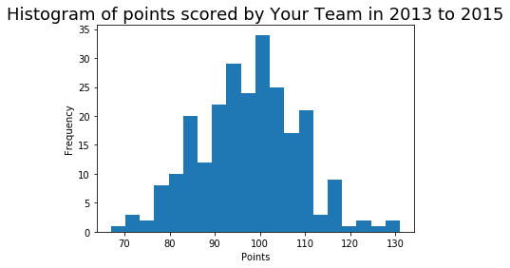
Looking at this histogram we can clearly see that over the three-year period of 2013-2015 the Milwaukee Bucks scored 98 points with a frequency of 34. We can also establish that this is a skewed-right histogram which signifies that the data mean of these variables is higher than the median which is the middle value of the data set provided.
I also chose a histogram to represent the points scored by the Chicago Bulls of the years 1996-1998. As seen with Milwaukee Bucks, this visualization correctly outputs the data to comprehend the frequency of points scored at an easier rate.

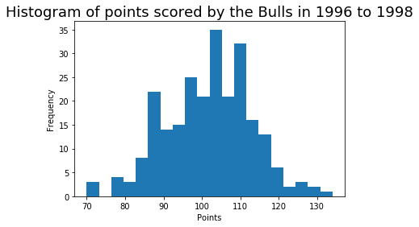

Examining this histogram, we can see that the Chicago Bulls over the three-year period of 1996-1998 scored 104 points with a frequency of 35. When examining this histogram further we can see clearly that there is a gap from points 74-76, this tells us that from the three-year period of 1996-1988 the Chicago Bulls did not finish a game with a score between 74-76. Along with the gap in this visualization we can determine that this distribution slightly skews to the left, signifying that the mean is less than the median.
Another attribute to data visualization is the ability to bring two forms of data together to create a comparison which helps even further in understanding the two pieces of data. You can accomplish comparison visualization with data either side by side or overlapping. Both sets of data on one visualization make it easier to pin-point areas to focus on first.
For the comparison visualization I again chose a histogram with the two sets of data on overlapping. A legend showing color in relation to the team with a noticeable color signifying the common data.
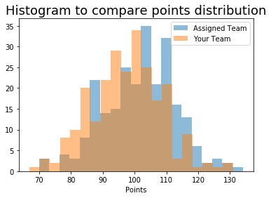

When comparing this data, we can see that the Chicago Bulls of 1996-19889 were slightly higher with a total points of 104 and frequency of 35. The overlapping data shows that combined the teams had total points of 104 at a frequency of 25, significantly lower than both of their stand-alone data. We can better see the skewed direction of each data, understanding even further how though the Chicago bulls have a higher peak in total points their average points all accumulated throughout the data set. In comparison we see how though the Milwaukee Bucks did not always score the most, their overall points in total will surpass their highest score.
Central tendency and variability rely on one another to analyze data distribution by understanding the center point and the dispersion of data (Frost,2025). In this summarization the central tendency focuses on where most total points occur and variability on how far each ending set of points is to one another.
Below are two tables: table 2 showing the statistical analysis of points scored by the Milwaukee Bucks during Home games, table 3 showing the statistical analysis of points scored by the Milwaukee Bucks during the Away games.

Table 2. Descriptive Statistics for Points Scored by Your Team in Home Games

Statistic Method | Value
Mean | 97.84
Median | 98.0
Variance | 122.69
Standard Deviation | 11.08

The statistical mean from this table tells us that when the Milwaukee Bucks played at home, they averaged a total points of 97.84. The median of tells us that the middle value of all away game was at 98.0. The variance tells us how spread out all the values are when in comparison to the mean, the variance that we see at the home games is 122.69. A larger number indicates that the values have a greater and more dispersed spread out around the average of the data. Standard deviation of 11.08 is the square root of the variance; putting the numerical value into a more relatable number when compared to the other data. From this table we can establish a bell-shape curve in any visualization supporting this data. The numerical data establishes that when a mean and median are close in relation a bell-shape will occur. By calculating the median of the data, we can have a more accurate central tendency.

Table 3. Descriptive Statistics for Points Scored by Your Team in Away Games

Statistic Method | Value
Mean | 96.97
Median | 97.0
Variance | 126.75
Standard Deviation | 11.26

The statistical mean from this table tells us that when the Milwaukee Bucks played away, they averaged a total-points of 96.97. The median of tells us that the middle value of all away game was 97.0. The variance tells us how spread out all the values are when in comparison to the mean, the variance that we see at the home games is 126.75. With a large number, with a numerical value over 4 in comparison to the home games, indicating the values disperse more widely, and below the average of the data. Standard deviation of 11.26 is the square root of the variance; putting the numerical value into a more relatable number when compared to the other data. From this table we can establish that a bell-shape curve will occur in any visualization supporting this data. The numerical data again establishes that when a mean and median are close in relation a bell-shape will occur.
Comparing these two tables we can clearly interpret that the Milwaukee Bucks had a better team performance at their home games. Home games with a mean of 97.85 with a standard deviation of 11.08 and away games with a mean of 96.97 with a standard deviation of 11.26. Though there is not a drastic numerical difference of only 1.18 in their mean value and a larger standard deviation in away games by .18. We can conclude that while at home the Milwaukee Bucks score more points with a smaller area of dispersion.
Confidence intervals estimate uncertainties by giving lower and upper limits indicating a range of values. They represent the confidence level of the parameters from the information needed by the data, in this case the relative skill of all teams withing the NBA compared to the Milwaukee Bucks during in the years 2013-2015 and all teams withing the NBA compared to the Chicago Bulls in the years 1996-1998.

Table 4. Confidence Interval for Average Relative Skill of Teams in Your Team’s Years

Confidence Level (%) | Confidence Interval
95% | (1502.02, 1507.18)

Teams during the years 2013-2015 there is a 95% confidence level that the teams will have relative skill falling between 1502.02 and 1507.18 points. The probability that a team has relative skill less than the Milwaukee Bucks during the 2013-2015 years is 0.2256 or 23%. With a low percentage it would be unusual if another team had a skill level less than the Milwaukee Bucks.

Table 5. Confidence Interval for Average Relative Skill of Teams in Assigned Team’s Years

Confidence Level (%) | Confidence Interval
95% | (1487.66, 1493.65)

Teams during the years 1996-1998 there is a 95% confidence level that the teams will have relative skill, falling between 1487.66 and 1493.65 points. The probability that a team has relative skill less than the Chicago Bulls during the 1996-1998 years is 0.9732 or 98%.
If we were to use a higher confidence level such as 99% in either scenario, we would see the interval shrink along with the percentage of probability. The higher we raise the confidence level the closer we get to be 100% correct in our interpretation with a smaller margin of error.
When comparing the 95% confidence levels of the 2013-2015 Milwaukee Bucks and the 1996-1998 Chicago bulls we can determine that the Chicago Bulls where a better team in 1996-1998 with 98% of NBA teams with a lower skill level, while the Milwaukee Bucks in 2013+-2015 only with 23% of NBA teams with a lower skill level. Showing that the Chicago Bulls where the better performing team.
The importance of these statistical analyses helps in understanding the average total points scored, the median value of total points scored, along with the distribution of the results. The confidence intervals give a range of values that the true population parameter is likely to fall into.
We can understand that the confidence intervals were much higher during the years 2013-2015 than 1996-1998, signifying a higher overall total points score throughout the league. Though 2013-2015 outscored 1996-1998 the Chicago Bulls were a better performing team when compared with the Milwaukee Bucks.
Milwaukee Bucks' coaching and management should adapt their strategies to strive for the performance standards set by the 1996-1998 Chicago Bulls, aiming to improve their overall team statistics.

Resources
Frost, J. (2025). Statistics By Jim: Measures of Variability: Range, Interquartile Range, Variance, and Standard Deviation. https://statisticsbyjim.com/basics/variability-range-interquartile-variance-standard-deviation/

